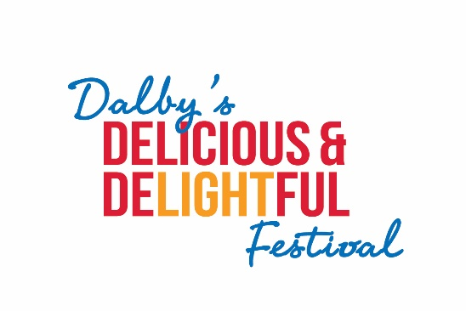

**21 -23 Aug, 2025**

**LIGHT INSTALLATION EXHIBITION**

*We invite you to help us make our festival* ***brighter*** *in 2025.*

*We are excited to have our own Dalby Festival Light Installation Exhibition showcasing our energy companies and their suppliers (Western Downs Regional Council promotes the region as the Energy Capital of Australia) as well as our businesses who are the backbone of our community. We believe this will be a truly unique display.*

*We envisage that each business will decorate a model (this could be a welded frame or an inflatable or (you may have an amazing idea) that depicts your business and decorate it with solar/battery lights.*

*The Light Installation Exhibition will be held over 3 nights along the pathways of Anderson Park from 21st – 23rd August to maximise the number of visitors.*

*GUIDELINES for EXHIBITORS*

* *Size of exhibits should have a base of no more than 3 square metres with a maximum height of 2 metres*
* *Exhibits should be decorated with solar or battery lights*
* *The festival will provide a corflute sign with your business name and logo and a brief explanation of your exhibit and why you chose the particular exhibit*
* *Exhibitors should have their own public liability insurance*
* *Exhibits should be delivered to Anderson Park and set up on Thursday morning 21st August and removed on Monday morning 25th August*
* *If you are seeking help with your design, B & B Fabrication, 46626268, may be able to assist*



**21 - 23 Aug, 2025**

**LIGHT INSTALLATION EXHIBITION**

**REGISTRATION FORM**

**We are deLIGHTed you have decided participate in our very first Light Installation Exhibition and create something unique for our visitors. Could you please complete this form and email to us by 31/07/2025.**

**Name of Business/Organisation:**

**Address:**

**Email:**

**Phone:**

**Contact Person:**

**Description of your model/exhibit:**

**Please attach your business logo:**

**Please attach Certificate of Currency for your Public Liability Insurance:**

*Thank you for your registration. Please email to* [*admin@deliciousanddelightful.com.au*](mailto:admin@deliciousanddelightful.com.au)

*For more information, contact Beth on 0419 645 671*